Title: | Door Control Module  SW Component DoorApp

History
Issue status  (Index) | Maturity/Date  (draft/invalid/valid)  (dd-mmm-yyyy) | Author  Department | Check/Release  Department | Description
1.0 | Draft  04-09-21 | Vicente Guerrero | Vicente Guerrero | Creation of the document

Table of Contents
1 Purpose 3
2 Definitions and abbreviations 3
3 Realization constraints and targets 3
4 SW Conceptual design 4
5 SW Component internal breakdown 4
5.1 Functional Decomposition 5
5.2 Function void DoorApp_Init ( ) 6
5.3 Function void DoorApp_Run( ) 6
5.4 Function int HandleButtonForActuation(int DoorSelected, int ButtonPressed) 6
5.5 Function int HandleConfortCmdforActuation (char *frame) 7
5.6 Function int HandleLockingRequest (char *frame, int *DoorToSelect) 8
5.7 Function int TransmitDCUforUnlockButton (char *frame, int DoorSelected, int UnlockBtnState) 9
5.8 Function int TransmitDCUforLockButton (char *frame, int DoorSelected, int LockBtnState) 11
5.9 Function int AutoLockProcess (char *dcu1frame, char *dcu2frame, char *dcu3frame, char *dcu4frame, float Speed, int powerMode) 12
5.10 Function int ManageLockError (uint isLockError, int powerMode) 14
5.11 Function int ManageButtonError (uint isButtonStuck, int powerMode) 15

Purpose
This document describes the design for the SW Component “DoorApp” from the Door Control Module Project, contained in the Software Architecture DCU.

Definitions and abbreviations
Definitions
SW Unit | The smallest unit of software that can be compiled and built.
SW Component | A piece of software and an element of the SW Architecture that implement the logic and algoritms of the software system.
Function | A set of logical instructions inside a SW Component that has input parameters and output parameters. It satisfies SW Requirements
Requirement | Condition to be accomplished that it is needed for the customers or stakeholders for the final product

Abbreviations
DCU – Door Control Module
SW - Software
App – Application
SDD- Software Detailed Design
SWA – Software Architecture
References
N° | Document name | Reference
1 | SW Architecture description | SWA_DCU
2 | SW Requirements | Traceability Matrix Template

Realization constraints and targets
With this software detail design it is expected that the developer can implement and build all the functions from the component in order to be tested and functional.

SW Conceptual design
The Software component to be designed is DoorApp from the SWA_DCU. This component is located in the application layer of the Software and it will implement the main logic for the Door Locking Application. Some characteristics are:
- Determine conditions for Remote And Manual Operation for Door Locking
- Determine and report Door locking status to CAN Bus
- Determine conditions for Auto Lock Operation.

SW Component internal breakdown
The next diagram shows the internal breakdown of the SW Component in SW Units. There will be just one SW Unit with one .c Source file and one .h Header file.
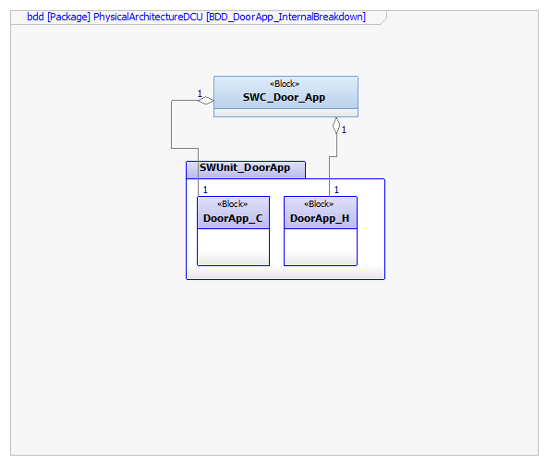

Functional Decomposition
The next diagram shows the functional decomposition of the operations performed by the SW Component Door App. Basically, the main function is DoorApp_Run, which calls and controls the other functions, data flow and interfaces from other components according to the SW Architecture.

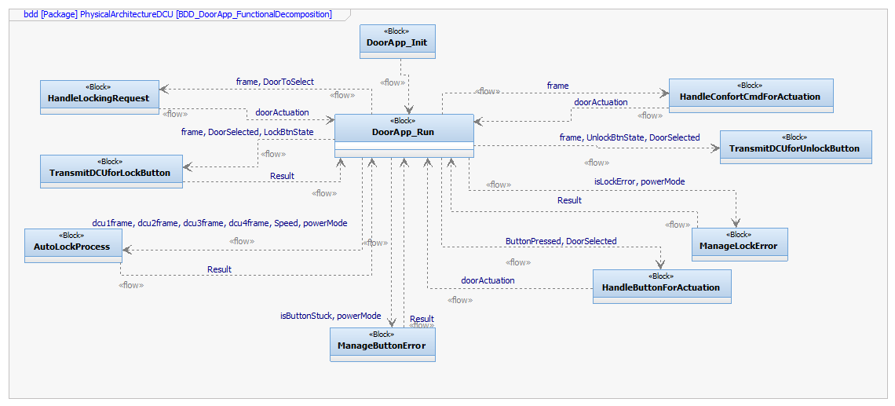
Function Description and Dynamic Behavior

Function void DoorApp_Init ( )

Description | Initialization of the Software Component DoorApp
Return Value | none
Precondition | Function can only be called when system has initialized or reset
Post condition | Function DoorApp_Run shall start after the execution of DoorApp_Init()
Error Conditions
Requirements

Function void DoorApp_Run( )
Description | Function that will perform the periodic operations and calls the rest of the functions in the Component except for the DoorApp_Init.
Return Value | none
Precondition | Function can only be called after the initialization of the SW Component.
Post condition | After the execution of this function, WindowApp component can start to execute its functions.
Error Conditions
Requirements

Function int HandleButtonForActuation(int DoorSelected, int ButtonPressed)
Description | This function validates the transitions and states from the LOCK_BTN and UNLOCK_BTN of the Door in order to perform an Door Actuation.
Parameter 1  DoorSelected | Indicates the selected Door for Actuation  0 – DRIVER_DOOR  1 – PASSENGER_DOOR  2 – REAR_LEFT_DOOR  3 – REAR_RIGHT_DOOR
Parameter 2  ButtonPressed | Indicates the button that has been pressed  0 – LOCK_BTN  1 – UNLOCK_BTN
Return Value | The Door Actuation to be performed  0 – LOCK_DOOR_ACTUATION  1 – UNLOCK_DOOR_ACTUATION  -1 – FUNCTION_ERROR
Precondition | Button status has to be requested before in order to call this function.
Post condition
Error Conditions | If another value for DoorSelected or ButtonPressed is input, then function shall return FUNCTION_ERROR.
Requirements | DCU_SWR_1, DCU_SWR_2, DCU_SWR_3, DCU_SWR_4.

Dynamic Behavior
State Chart
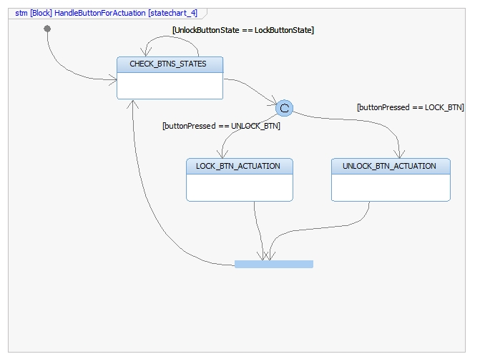

Function int HandleConfortCmdforActuation (char *frame)
Description | This function monitors the transitions and states of the ConfortCmd byte from the BCM_2 frame and performs an Actuation.
Parameter 1  *frame | Pointer to the BCM_2 frame
Parameter 2  ButtonPressed | Indicates the button that has been pressed  0 – LOCK_BTN  1 – UNLOCK_BTN
Return Value | The Door Actuation to be performed  0 – LOCK_DOOR_ACTUATION  1 – UNLOCK_DOOR_ACTUATION  -1 – FUNCTION_ERROR
Precondition | BCM_2 frame has to be requested before in order to call this function.
Post condition
Error Conditions | If a different frame than BCM_2 is input, then function Will return FUNCTION_ERROR
Requirements | DCU_SWR_8, DCU_SWR_9

Dynamic Behavior
State Chart

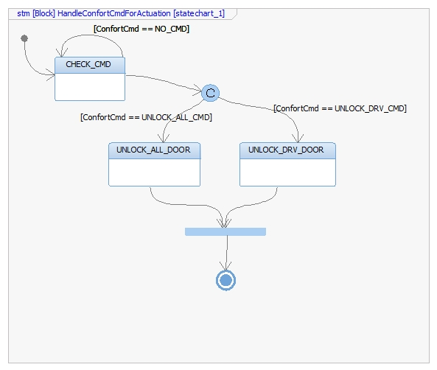

Function int HandleLockingRequest (char *frame, int *DoorToSelect)
Description | This function monitors the LockingReq byte from DCU_1 and DCU_2 frames and according to a value, it performs a Door Actuation.
Parameter 1 Input  *frame | Pointer to the DCU frame to analyze
Parameter 2 Output  *DoorToSelect | Pointer to a buffer that will store the door to be selected.  0 – DRIVER_DOOR  1 – PASSENGER_DOOR  2 – REAR_LEFT_DOOR  3 – REAR_RIGHT_DOOR
Return Value | The Door Actuation to be performed  0 – LOCK_DOOR_ACTUATION  1 – UNLOCK_DOOR_ACTUATION  -1 – FUNCTION_ERROR
Precondition | BCM_2 frame has to be requested before in order to call this function.
Post condition
Error Conditions | If a different frame than DCU_1 or DCU_2 is input, then function shall return FUNCTION_ERROR
Requirements | DCU_SWR_10, DCU_SWR_11, DCU_SWR_12, DCU_SWR_13, DCU_SWR_14, DCU_SWR_15, DCU_SWR_16, DCU_SWR_17, DCU_SWR_18, DCU_SWR_19
Dynamic Behavior
State Chart

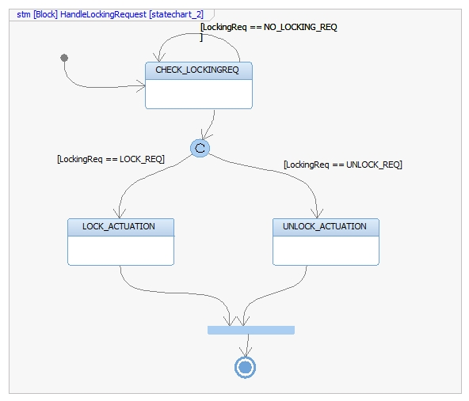

Function int TransmitDCUforUnlockButton (char *frame, int DoorSelected, int UnlockBtnState)
Description | This function handles the unlock button transitions from DCU_1 or DCU_2 frame and according to the value, it transmits LockingReq with a value for an specific Door.
Parameter 1 Input  *frame | Pointer to the DCU frame to analyze
Parameter 2 Input  DoorSelected | Indicates the selected door  0 – DRIVER_DOOR  1 – PASSENGER_DOOR  2 – REAR_LEFT_DOOR  3 – REAR_RIGHT_DOOR
Parameter 3 Input  UnlockBtnState | Indicates the status of Unlock Button.  0 – BTN_NOT_PRESSED  1 – BTN_PRESSED
Return Value | Operation result  0 – FUNCTION_OK  -1 – FUNCTION_ERROR
Precondition | DCU_1 and DCU_2 frames have to be requested before in order to call this function.  UnlockButton Status has to be requested.
Post condition | DCU frame shall be transmitted with the new value on the LockingReq byte.
Error Conditions | If a different frame than DCU_1 or DCU_2 is input, then function shall return FUNCTION_ERROR.  If another value for DoorSelected or UnlockBtnStatus is input, then function shall return FUNCTION_ERROR.
Requirements | DCU_SWR_26, DCU_SWR_28

Dynamic Behavior
State Chart

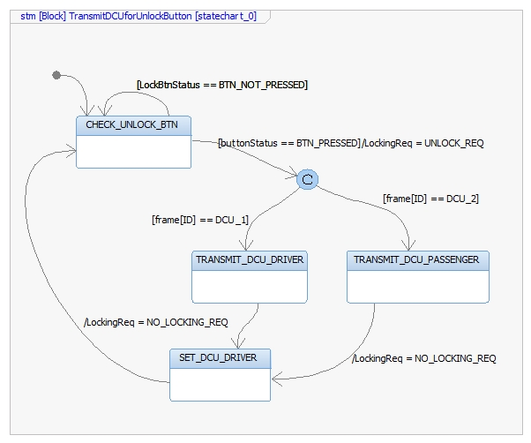

Function int TransmitDCUforLockButton (char *frame, int DoorSelected, int LockBtnState)
Description | This function handles the button transitions from DCU_1 frame and according to the values, it transmits LockingReq with a value for an specific Door.
Parameter 1 Input  *frame | Pointer to the DCU frame to analyze
Parameter 2 Input  DoorSelected | Indicates the selected door  0 – DRIVER_DOOR  1 – PASSENGER_DOOR  2 – REAR_LEFT_DOOR  3 – REAR_RIGHT_DOOR
Parameter 3 Input  LockBtnState | Indicates the status of Lock Button.  0 – BTN_NOT_PRESSED  1 – BTN_PRESSED
Return Value | Operation result  0 – FUNCTION_OK  -1 – FUNCTION_ERROR
Precondition | DCU_1 frame have to be requested before in order to call this function.  LockButton Status has to be requested.
Post condition | DCU frame shall be transmitted with the new value on the LockingReq byte.
Error Conditions | If a different frame than DCU_1 is input, then function shall return FUNCTION_ERROR.  If another value for DoorSelected or LockBtnStatus is input, then function shall return FUNCTION_ERROR.
Requirements | DCU_SWR_27

Dynamic Behavior
State Chart

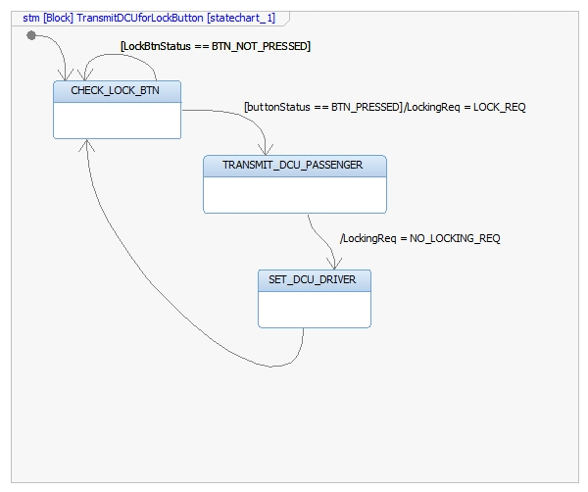

Function int AutoLockProcess (char *dcu1frame, char *dcu2frame, char *dcu3frame, char *dcu4frame, float Speed, int powerMode)
Description | This function performs an AutoLocking Function according to the DoorLock Status of each door, the vehicle speed and the system power mode. After the analysis the function reports a LockingRequest.
Parameter 1 Input  *dcu1frame | Pointer to the first DCU frame to analyze
Parameter 2 Input  * dcu2frame | Pointer to the second DCU frame to analyze
Parameter 3 Input  * dcu3frame | Pointer to the third DCU frame to analyze
Parameter 4 Input  * dcu4frame | Pointer to the fourth DCU frame to analyze
Parameter 5 Input  Speed | Indicate the current vehicle speed
Parameter 6 Input  powerMode | Indicates the current System Power Mode  0 – OFF  1 – RUN
Return Value | Operation result  0 – FUNCTION_OK  -1 – FUNCTION_ERROR
Precondition | All DCU frames have to be requested before in order to call this function.  Vehicle Speed and System Power Mode have to be requested.
Post condition | Driver door shall transmit its DCU frame with the LOCK_REQ value on the LockingReq byte.
Error Conditions | If a different frame than DCU_1 to DCU_4 is input, then function shall return FUNCTION_ERROR.  If another value for powerMode is input, function shall return FUNCTION_ERROR.
Requirements | DCU_SWR_29
Dynamic Behavior
State Chart

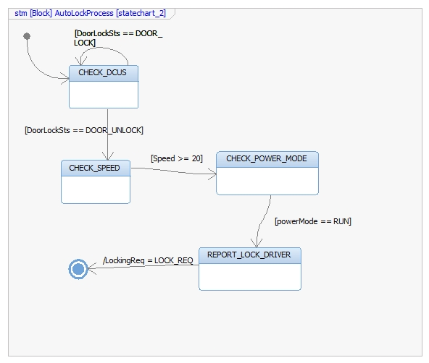

Function int ManageLockError (uint isLockError, int powerMode)
Description | This function manages the Door Lock errors
Parameter 1 Input  isLockError | Value that indicates if a Door Lock Error has occured  0 – FALSE  1 – TRUE  Any other value greater than 1 shall be considered as TRUE.
Parameter 6 Input  powerMode | Indicates the current System Power Mode  0 – OFF  1 – RUN
Return Value | Operation result  0 – FUNCTION_OK  -1 – FUNCTION_ERROR
Precondition | DoorLock Status has to be requested.  System Power Mode have to be requested.
Post condition
Error Conditions | If another value for powerMode is input, function shall return FUNCTION_ERROR.
Requirements | DCU_SWR_147

Dynamic Behavior
State Chart

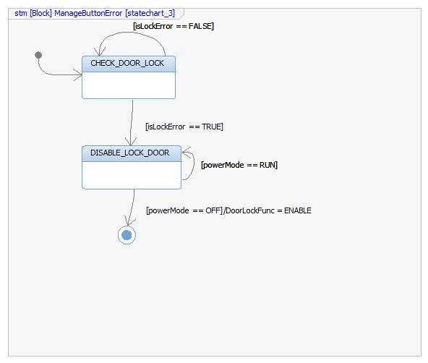

Function int ManageButtonError (uint isButtonStuck, int powerMode)
Description | This function manages the Button Stuck
Parameter 1 Input  isButtonStuck | Value that indicates if a Button Stuck has occured  0 – FALSE  1 – TRUE  Any other value greater than 1 shall be considered as TRUE.
Parameter 6 Input  powerMode | Indicates the current System Power Mode  0 – OFF  1 – RUN
Return Value | Operation result  0 – FUNCTION_OK  -1 – FUNCTION_ERROR
Precondition | Button Status has to be requested.  System Power Mode have to be requested.
Post condition
Error Conditions | If another value for powerMode is input, function shall return FUNCTION_ERROR.
Requirements | DCU_SWR_148

Dynamic Behavior
State Chart

